The problem we addressed in our project is to predict the future prices of Vakko.

A similar example of this project is as follows:

<https://www.kaggle.com/code/dmitrybunin/store-sales-prediction-with-etna-library>

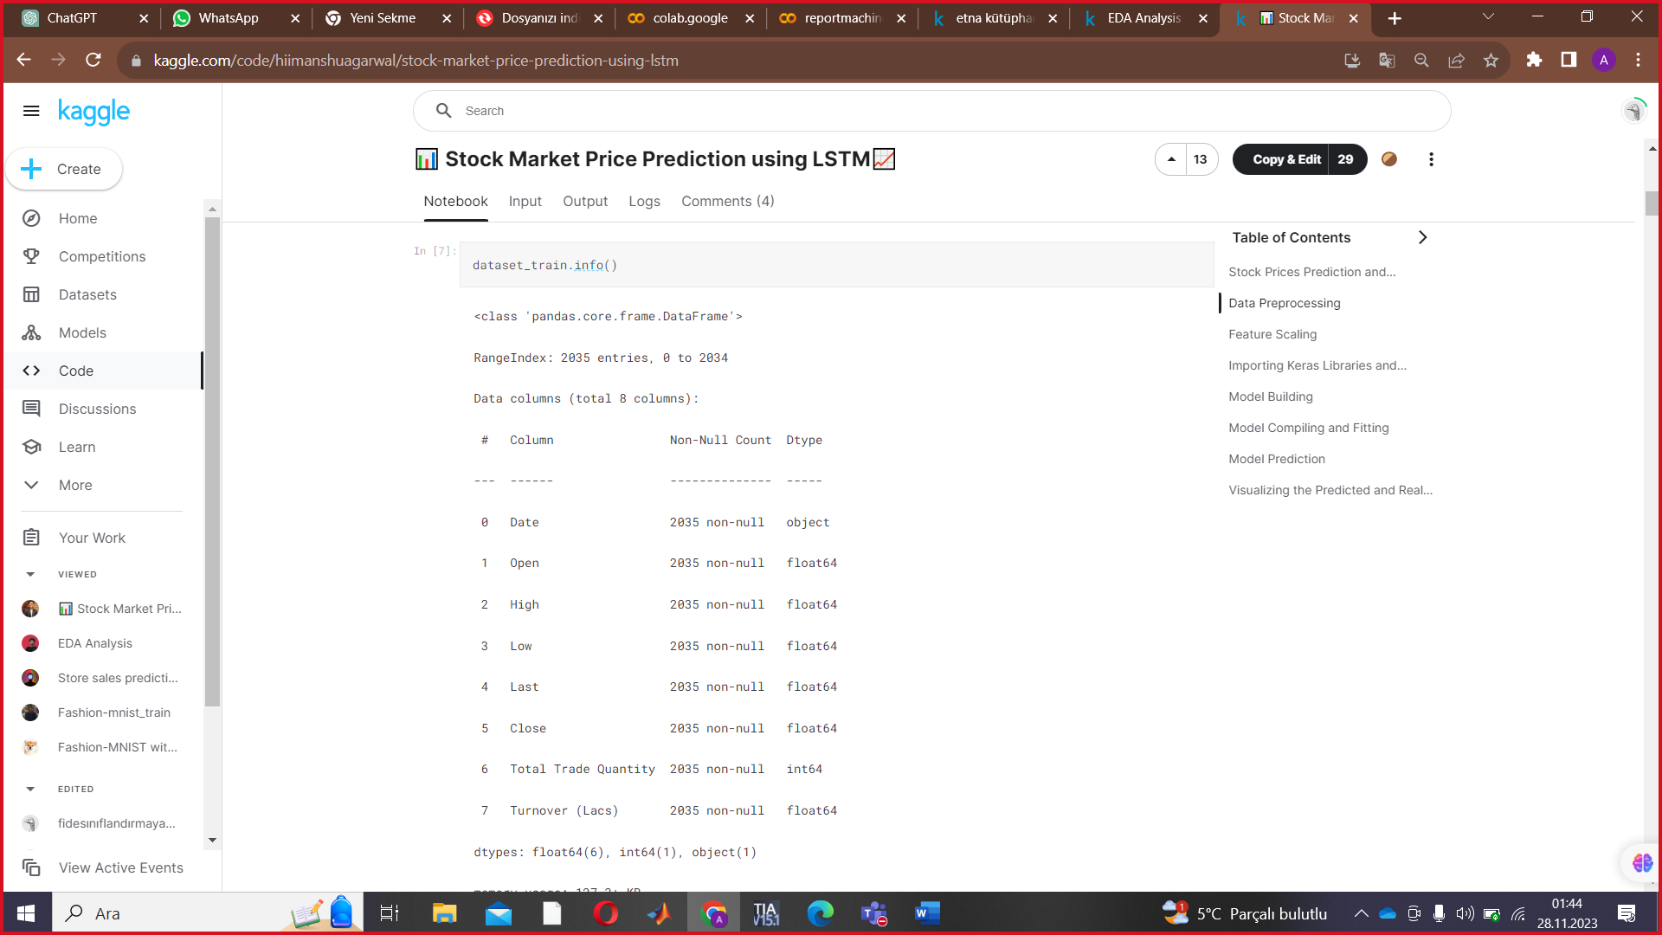

metin, ekran görüntüsü, yazılım, bilgisayar simgesi içeren bir resim

Açıklama otomatik olarak oluşturuldu

metin, ekran görüntüsü, yazılım, bilgisayar simgesi içeren bir resim

Açıklama otomatik olarak oluşturuldu

We used the following methodologies to develop this project:

-Deep learning

-Regression

-Normalization graph

Experimental evaluations are as follows:

NORMALIZATION GRAPH WE MADE IN OUR PROJECT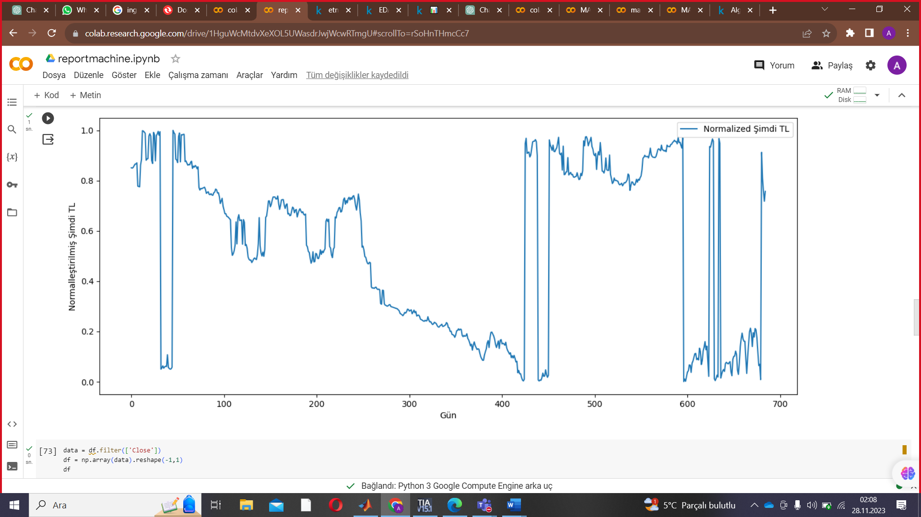

DEEP LEARNING IN OUR PROJECT (EPOCH)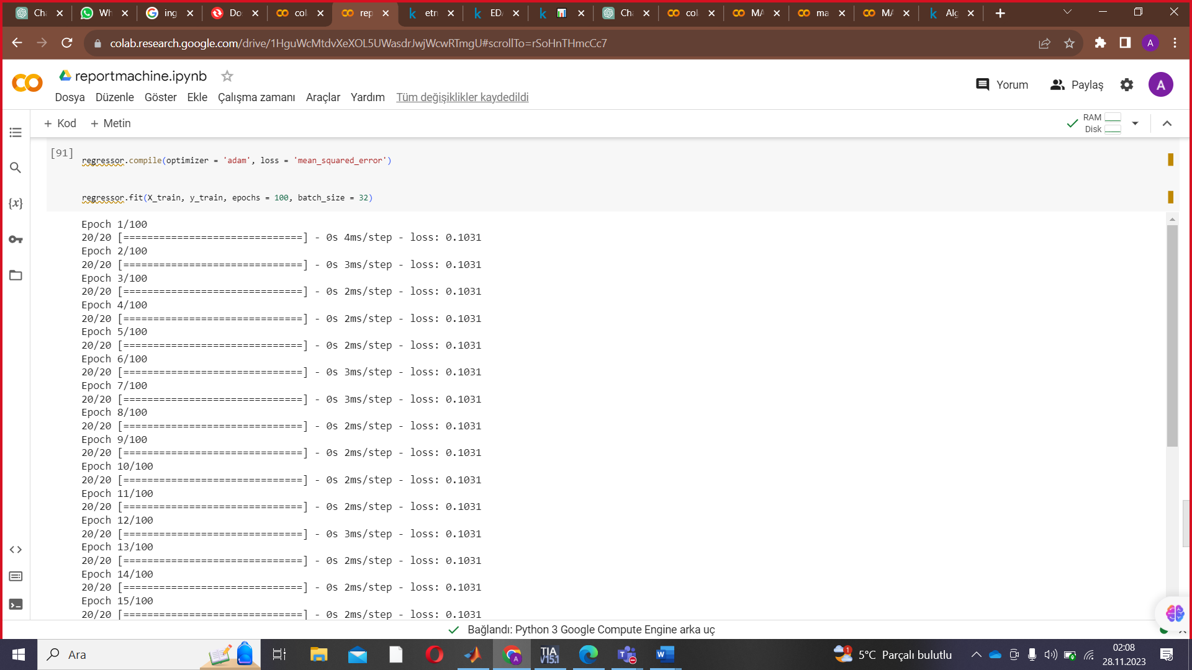

Traditional approaches to stock market analysis and stock price prediction include fundamental analysis, which looks at a stock's past performance and the general credibility of the company itself, and statistical analysis, which is solely concerned with number crunching and identifying patterns in stock price variation. The latter is commonly achieved with the help of Genetic Algorithms (GA) or Artificial Neural Networks (ANN's), but these fail to capture correlation between stock prices in the form of long-term temporal dependencies. Another major issue with using simple ANNs for stock predictions the phenomenon of exploding / vanishing gradient, where the weights of a large network either become too large or too small (respectively), drastically slowing their convergence to the optimal value.

Model Development Using LSTM (Recurrent Neural Network Type) We are planning to further develop our project by using Streamlit, improving RNN and adding a few more methods.